Accurate performance analysis of chaos-based code tracking in presence of multipath fading

R. Vali, S.M. Berber and S.K. Nguang

Abstract: A new statistical method for examining correlation of chaos-based systems is applied to the analysis of a chaos-based non-coherent tracking loop in presence of Rayleigh distributed multipath fading. The motivation behind this approach is the lack of accuracy in the treatment of chaos-based code tracking in presence of Rayleigh fading. The distributions of the critical points on S-curve have been derived in the fading case and shown to closely match the simulation results.

Introduction: Chaos-based spread spectrum communication has been an active area of research since the late 90s. Many different communication schemes have been proposed some of which describe systems that use chaos-based spreading codes generated from iterative maps (like Logistic map) in a direct sequence spread spectrum (DS-SS) scenario. The performance of chaos-based DS-SS systems hinges on the ability of transmitter and receiver to synchronise through code acquisition and tracking. The synchronisation of chaos-based spreading codes has been of interest to researchers recently, and both acquisition and tracking have been treated in [1-3]. However, the approach used for the treatment of code tracking in [1, 2] is not accurate because it does not take the non-binary nature of chaotic spreading codes into account. In this letter we aim to use a statistical correlation approach reported in [4] to find accurate expressions for the tracking loop S-curve in a multipath Rayleigh fading scenario and compare it to the noise only case.

System Model: Fig. 1 presents the delay locked loop (DLL) which is being investigated here in the presence of Rayleigh multipath fading. The DLL makes use of two correlators, one advanced by say half a chip time (early gate) and the other one delayed by the same amoun (late gate). The error function () which is the subtration of the square of the two correlators is filtered and fed to the voltage cotrolled oscillator (VCO) to correct the tracking error between the incoming chaotic pilot sequence and the locally generated one. It is assumed that code acquisitoion to within one chip duration has been acheieved in this letter. The square law devices are used to eliminate the residual phase difference between the local oscillator and the receieved sinusoidal carrier.
The first step is to find the ocrrelation of the incoming chaotic sequence and the locally generated one, i.e. the output of the BPF in Fig. 1. This can be described as
,
where is the length of the correlation, is the chaotic pilot which in this case is generated form a Logistic map [4] and is the index for the time delay. Extending on [4], the correlation function for a faded case where the fading coefficient changes every bit can be described as two separate parts, the near zero cross-correlation part and the auto-correlation peak. Therefore we have
,
and
The cross-correlation function for unaligned sequences is shown in (2). The fading coefficients are denoted by where is the number of bits in the correlation function. The tracking loop correlation function covers many bits because of high time resolution requirements. Eqn. (3) shows the auto-correlation function when the two sequence are aligned in time and corresponds to the faded auto-correlation peak. As shown in [4] both (2) and (3) can be considered to be random variables and if the value of is large, by the virtue of the central limit theorem, they can be considered to have Gaussian distributions with certain means and variances. The case for small without fading is covered in [5].
Results: The correlation results can be statistically expressed as
,
for the cross-correlation part and

for the auto-correlation peak. In (4) and (5) corresponds to the mode of the Rayleigh fading, is the number of bits in the correlation function and is the additive white Gaussian noise (AWGN) variance. The expressions in (4) and (5) will simplify to the corresponding equations in [4] if Rayleigh fading is not present.
We concentrate on expressing the S-curve salient points in a statistical way for a noise and fading case scenario. Fig. 2 shows the upper and lower bounds for a tracking loop S-curve when no AWGN or fading is present in the channel and the salient points are denoted by A and B. Given the S-curve is the result of the subtraction of the two squared correlation functions, for points A and B we have the convolution of a central chi-square with a non-central chi-square distribution and a convolution of two central chi-square distributions respectively. Mathematically these distributions can be described as
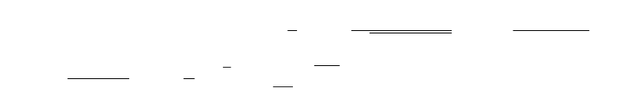
for point A and
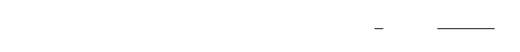
for point B. In (6) and (7), and are squares of and normalised by variance respectively. is a modified Bessel function and is the non-centrality parameter for which can be expressed as 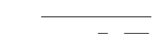.
Fig. 3 shows the comparison of simulated results and the numerical integration from (6). The case without Rayleigh fading reported in [4] is also shown for comparison purposes. As can be seen, the mean of is lower in the fading case, because Rayleigh fading has affected adversely the auto-correlation peak of the chaotic spreading sequences. The shifting of the whole distribution to the left indicates a smaller mean value for the correlation peak, which corresponds to a less than accurate S-curve for the DLL. This less accurate S-curve will result in a higher variance of tracking error. shows no difference from the previous results because it has been normalised by the variance of .

Conclusion: In this letter, we analytically predict the statistical distribution of the S-curve peak of a chaos-based DLL tracking loop in presence of AWGN and Rayleigh distributed multipath fading using a new statistical approach in describing the correlation of chaotic sequences. The analytical result shows close agreement with the simulation results and is useful is seeing the adverse effects of channel fading on the S-curve of the chaos-based DLL. The problem of chaos-based tracking in the presence of fading had not been considered in a statistical sense before making the available results less reliable. This letter addresses this problem by applying a statistical method to a chaos-based DLL in Rayleigh fading conditions.

References
1 Vali, R.; Berber, S. & Nguang, S. K. ‘Analysis of a Chaos-Based Non-Coherent Delay Lock Tracking Loop’, Communications (ICC). 2010 IEEE International Conference on, 2010, pp. 1-6

2 Vali, R.; Berber, S. & Nguang, S. ‘Effect of Rayleigh fading on non-coherent sequence synchronization for multi-user chaos based DS-CDMA’, Signal Processing, 2010, 90, 1924-1939

3 Kaddoum, G.; Roviras, D.; Charge, P. & Fournier-Prunaret, D. ‘Robust synchronization for asynchronous multi-user chaos-based DS-CDMA’, Signal Processing, 2009, 89, 807-818

4 Vali, R.; Berber, S. & Nguang, S. K. ‘Analysis of Chaos-based Code Tracking Using Chaotic Correlation Statistics’, IEEE Trans. on Circuits and Systems I, (in press)

5 Kaddoum, G.; Charge, P.; Roviras, D. & Fournier-Prunaret, D. ‘A methodology for bit error rate prediction in chaos-based communication systems’, Circuits, Systems, and Signal Processing, 2009, 28, 925-944

Authors’ affiliations:

R. Vali, S.M. Berber and S.K. Nguang (Department of Electrical and Computer Engineering, The University of Auckland, Private Bag 92019, Auckland, New Zealand)

E-mail: r.vali@ieee.org

Figure captions:

Fig. 1 Schematic block diagram of the DLL.

Fig. 2 Upper and lower-bounds for the tracking loop without AWGN and Rayleigh fading (adapted from [4]).

Fig. 3 Comparison between predictions of (6) and the simulations results, the AWGN only case (presented in [4]) is also presented to show the detrimental effects of Rayleigh fading on the S-curve.

Figure 1

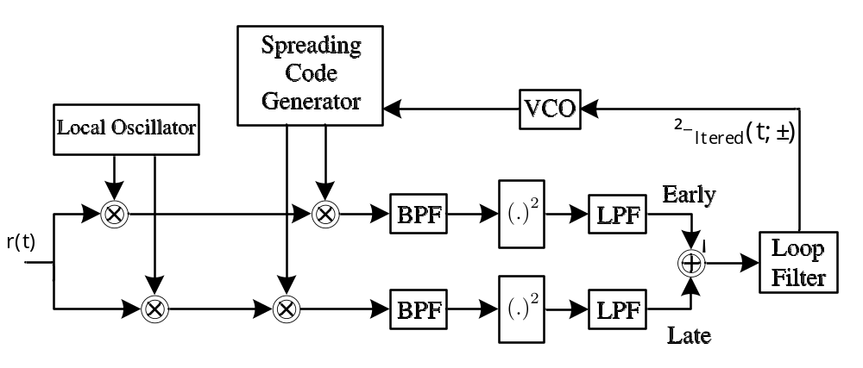

Figure 2

Figure 3

